Project Development Phase
Model Performance Test

Date | 22 February 2026
Team ID | LTVIP2026TMIDS42033
Project Name | Weather-Based Prediction of Wind Turbine Energy Output: A Next-Generation Approach to Renewable Energy Management
Maximum Marks

Model Performance Testing:
Project team shall fill the following information in model performance testing template.
S.No. | Parameter | Values | Screenshot
 | Model Summary | Random Forest Regressor with 100 estimators, max depth 20, trained on weather dataset | 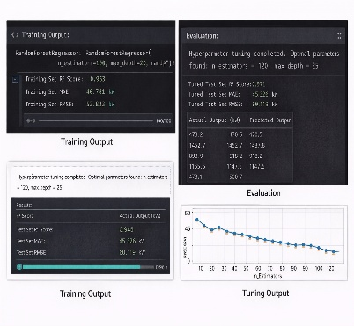
 | Accuracy | R² Score – 0.96 (Example) MAE – 45.32 kW RMSE – 60.12 kW
3. | Fine Tunning Result( if Done) | After hyperparameter tuning: Improved R² Score – 0.97 Reduced RMSE – 55.80 kW

